Part 2 Regression

Section 2

Feature Scaling
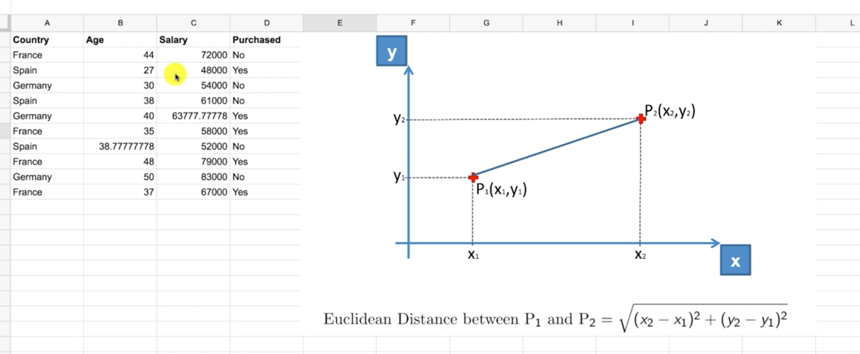
- The Euclidean distance between two points is the square root of the sum of the square cordinates.

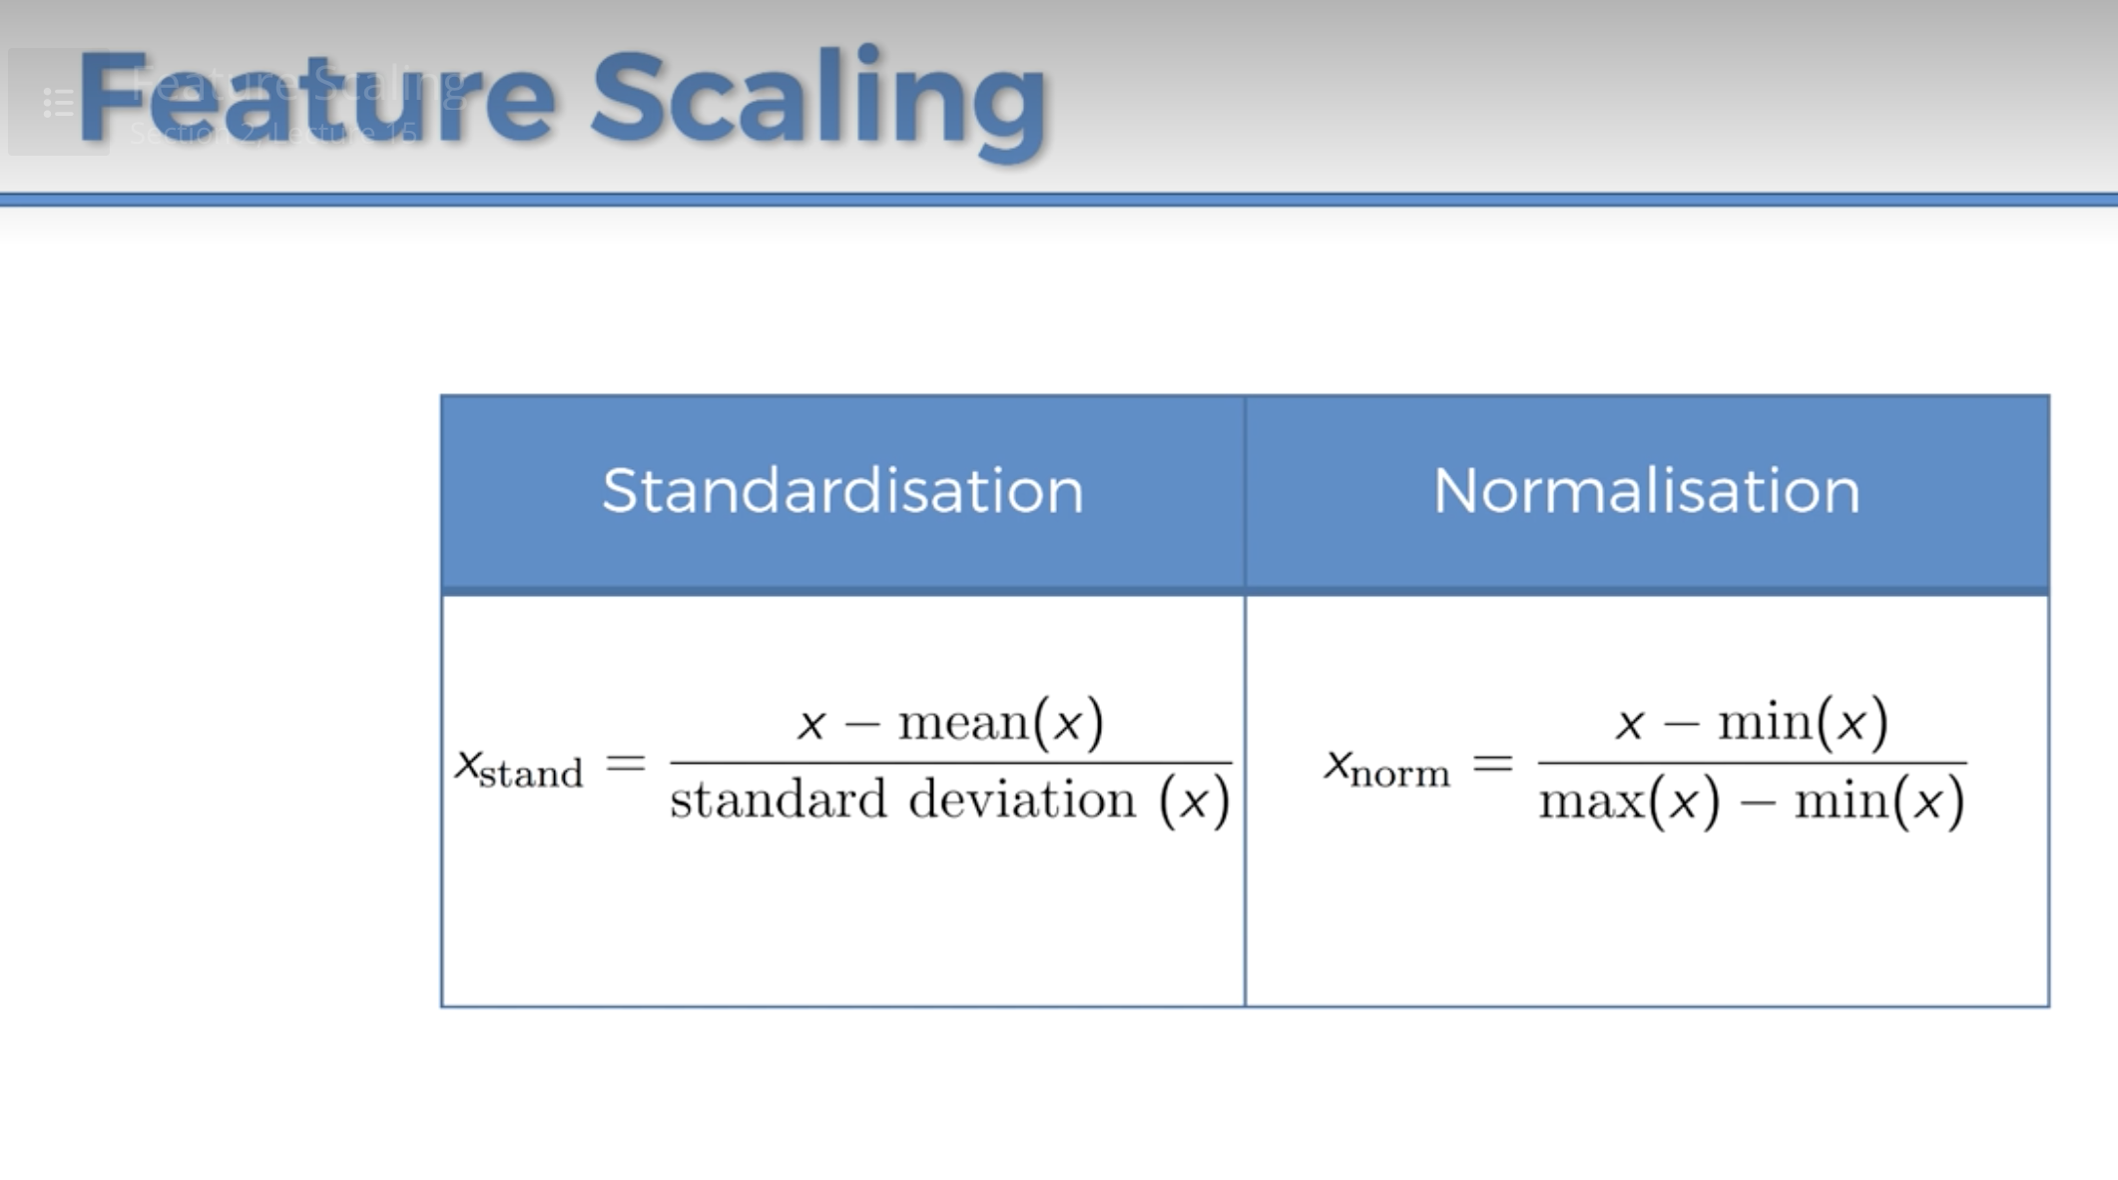

Standardisation
For each observation and each feature you withdraw the mean value of all the values of the feature and you divide it by the standard deviation.

Normalization
Substract your observation feature X by the minimum value of all the future values and you divide it by the maximum of your future values and the mimimum of the feature values.

Section 4

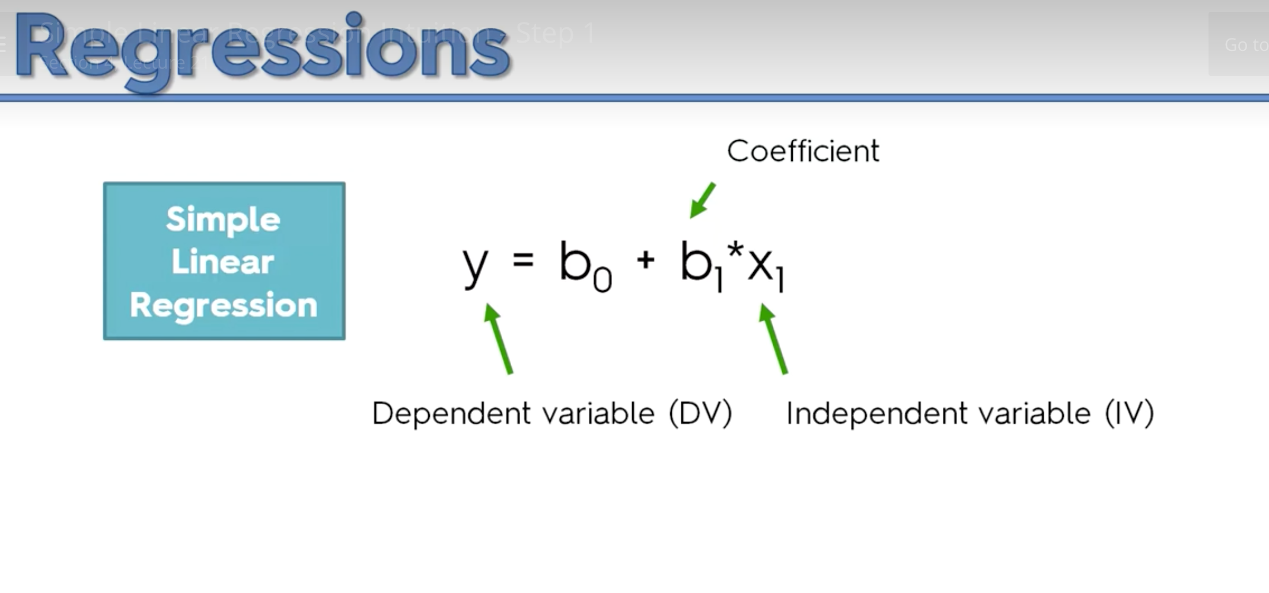
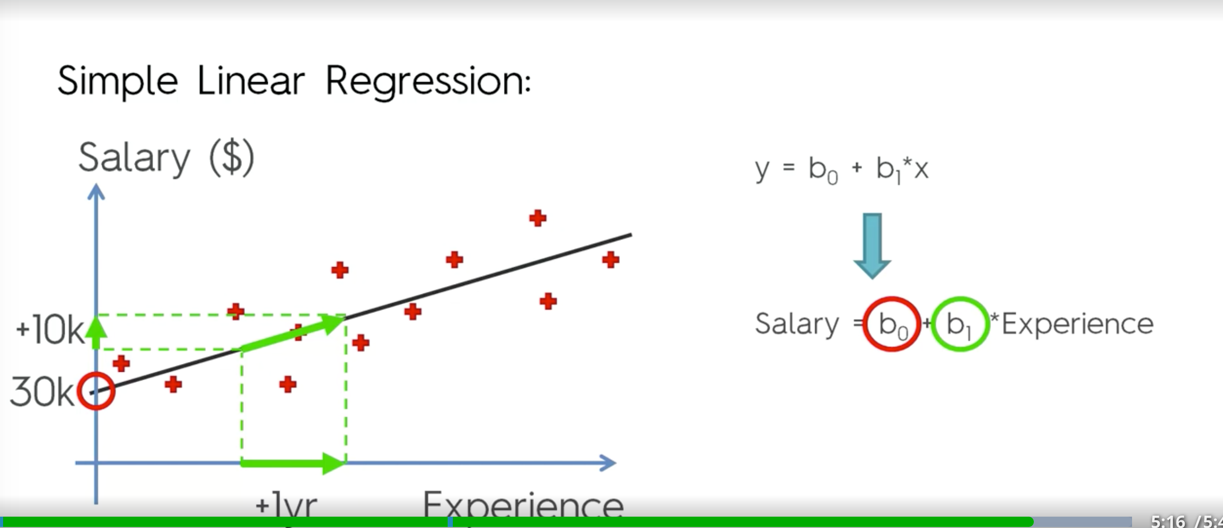
- b0: the basic salary if the experience = 0
- b1: the coeffient which creates the slop multiplied by X value.

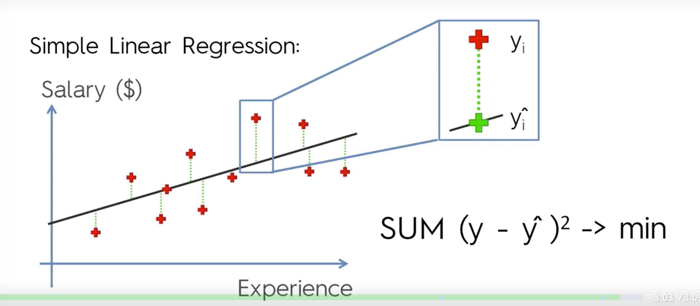
- Y_{i} = Actual position.
- Y^_{i} = Model value

Section 5: Multiple Linear Regression
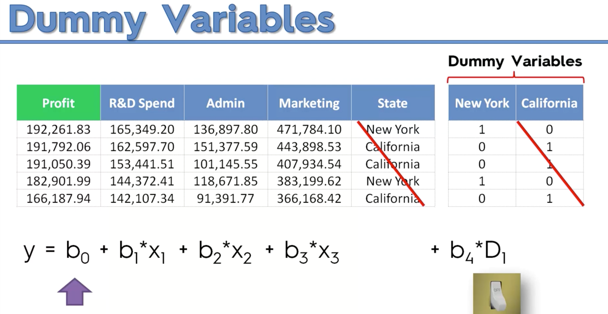
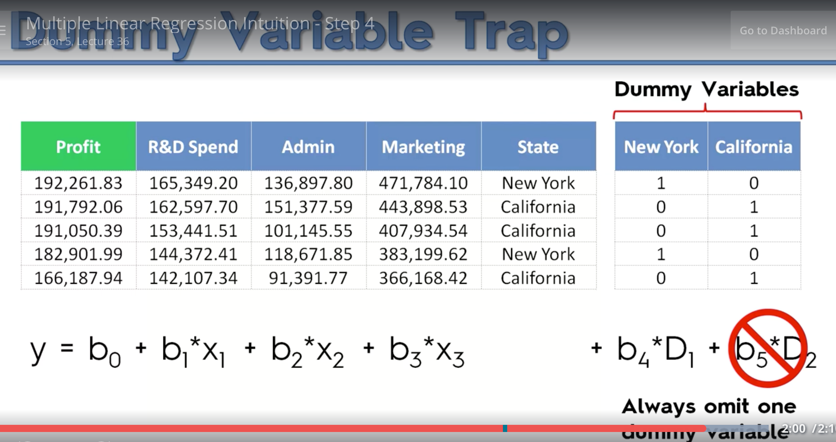

Section 6: Polinomial Regression
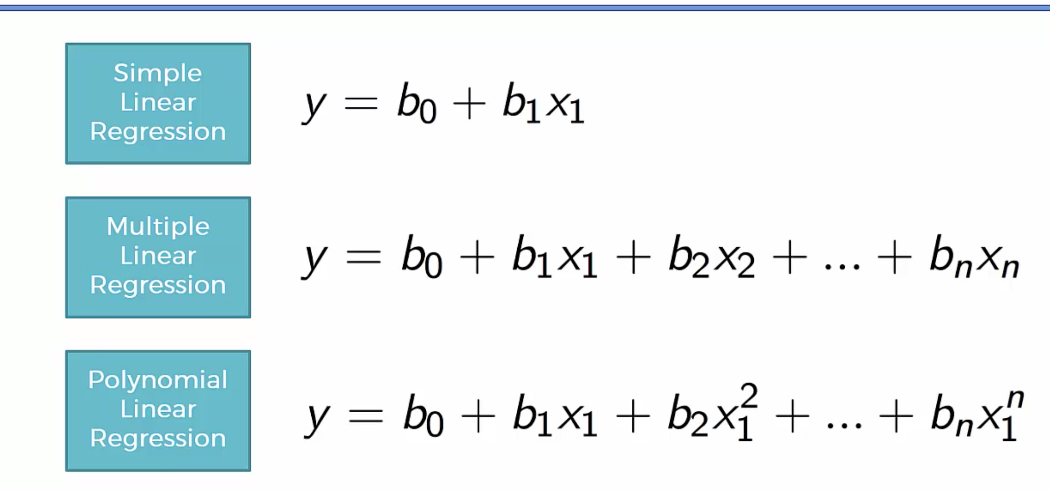
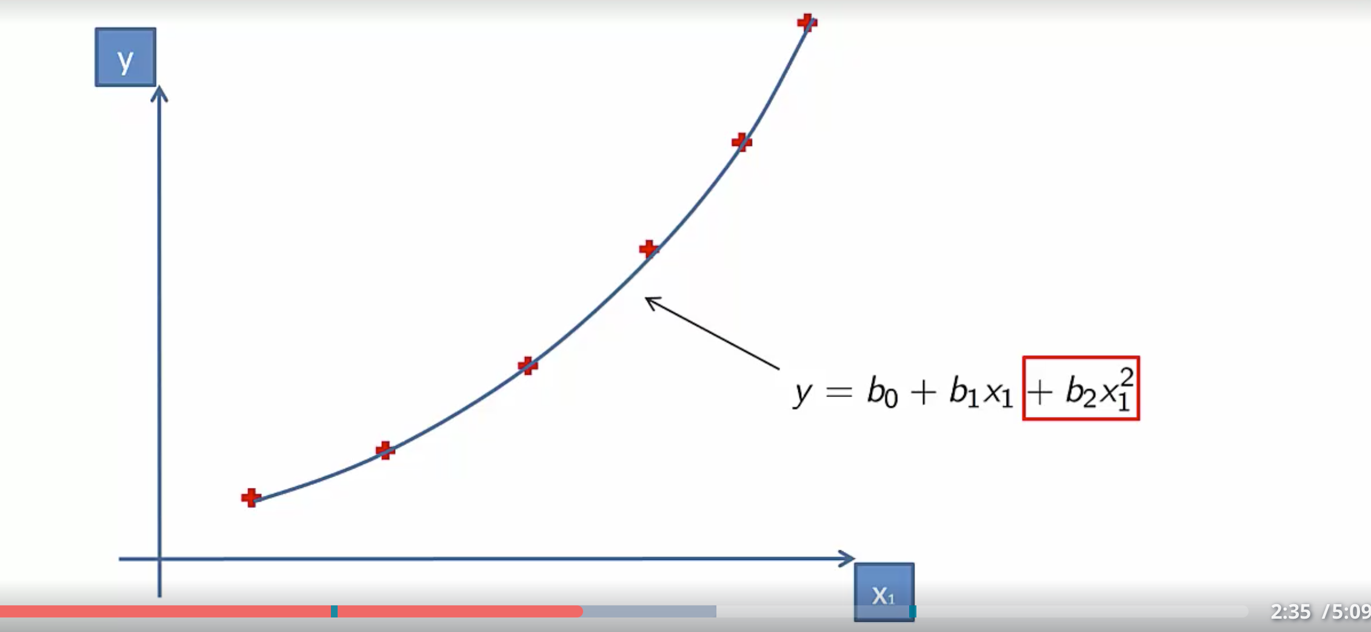

Section 8: Decision Tree Intuition

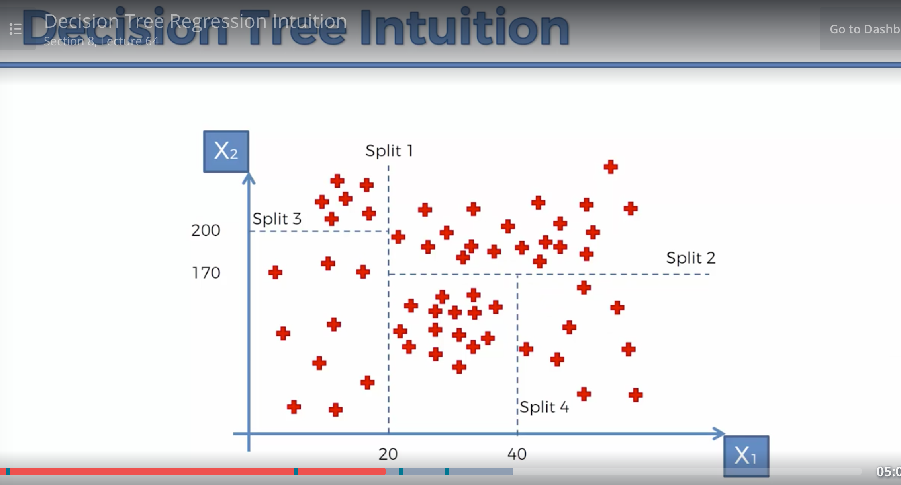
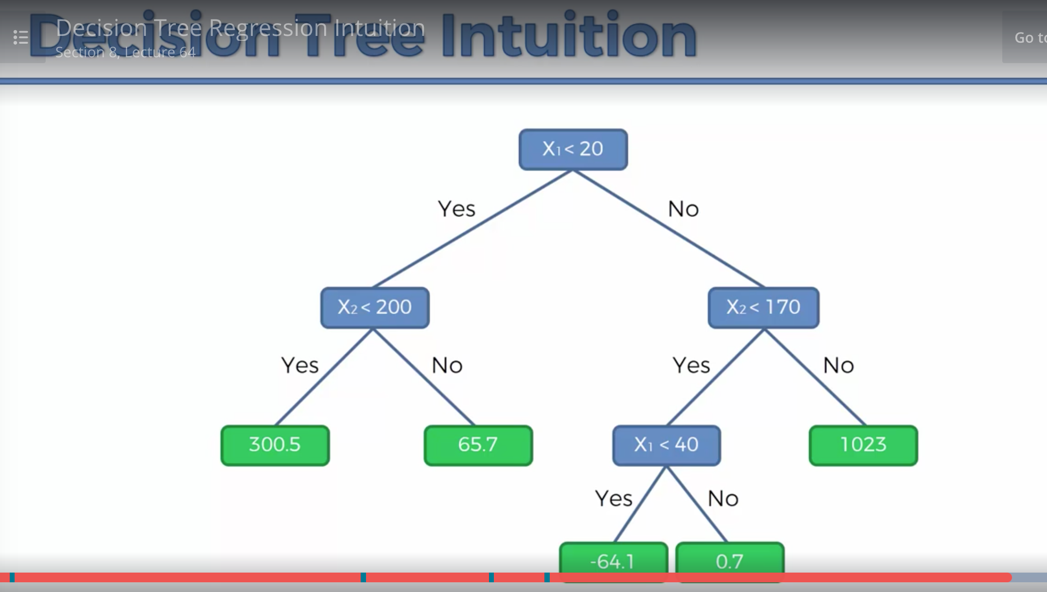

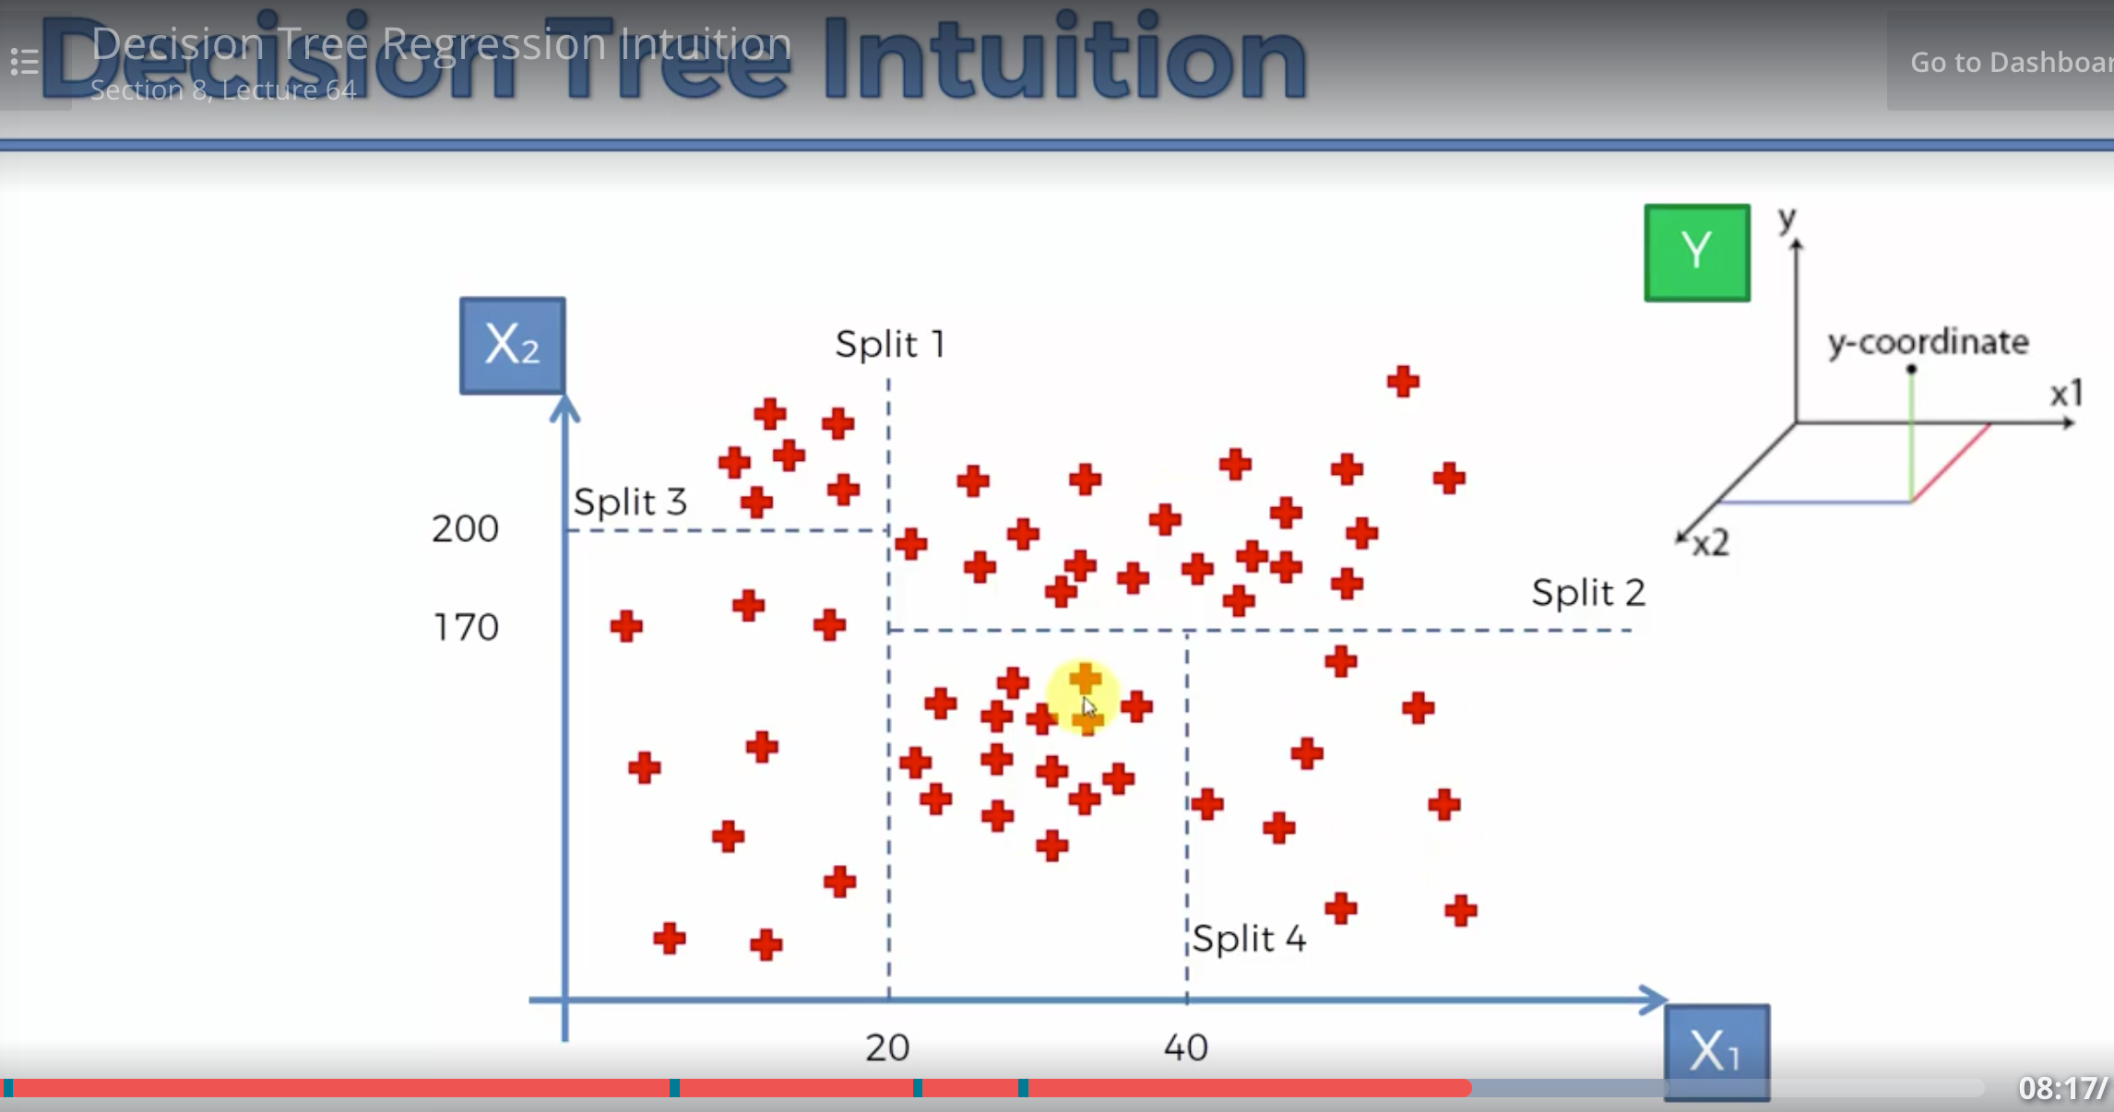

R Squared



